
City of Middleton:

Tax Increment District #5 Report

March 1, 2014

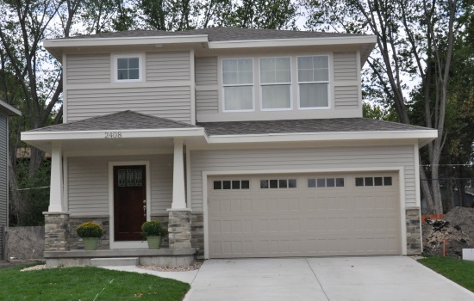
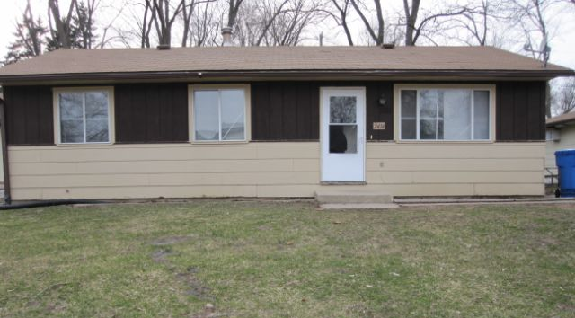
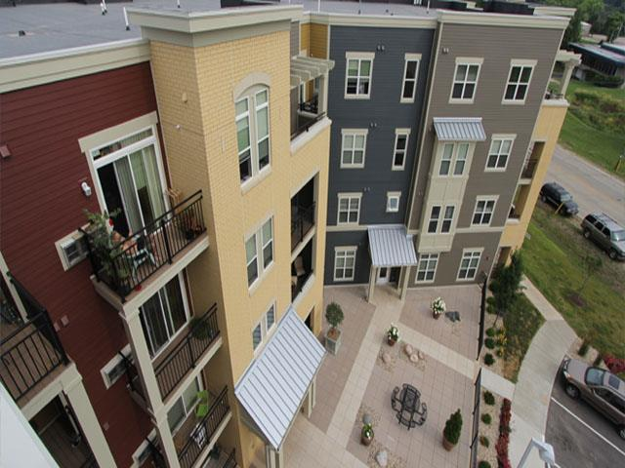

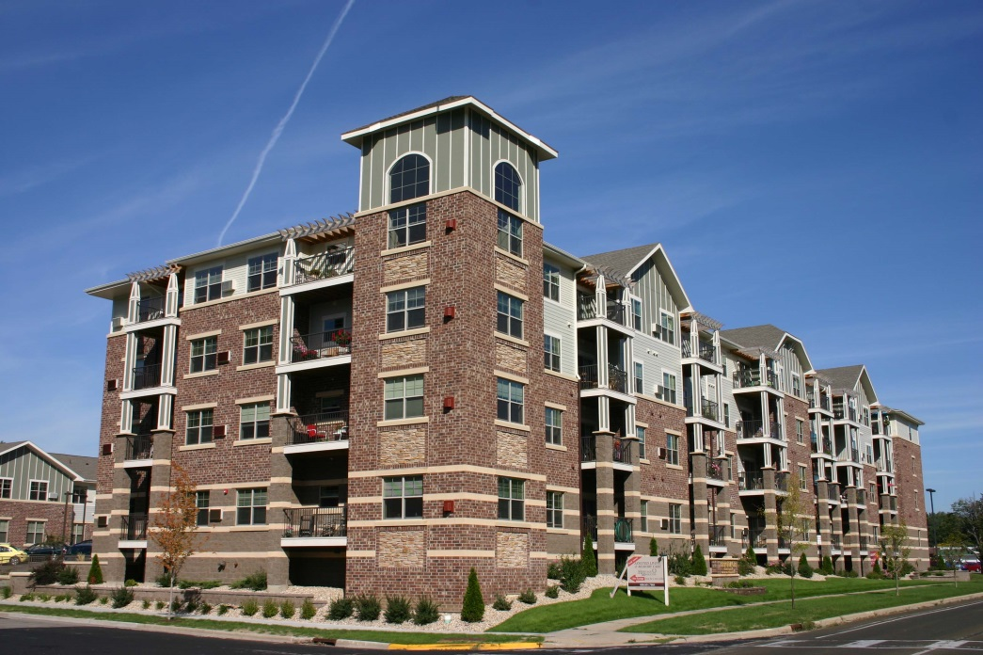
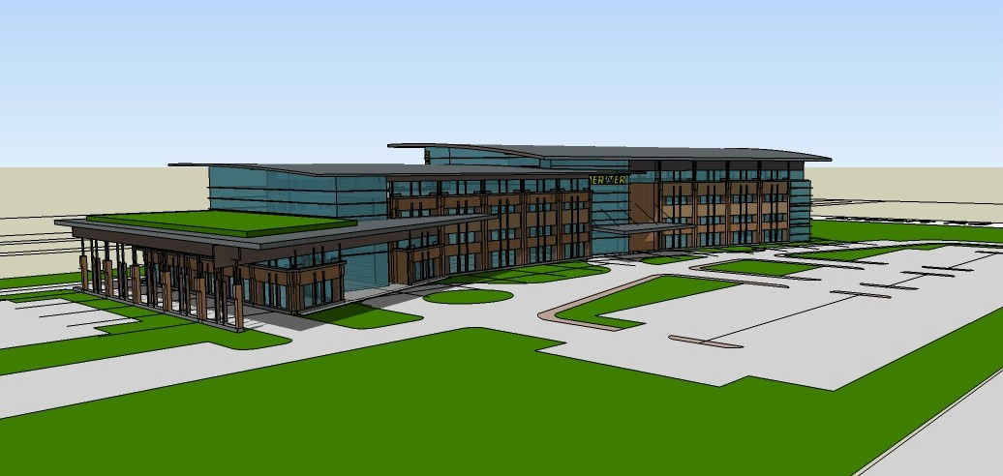
Introduction

The City of Middleton created Tax Incremental Financing District #5 (TID #5) in 2009. In the Project Plan, the estimate for projected expenses for the life of TID #5 (through the year 2031) was listed at $104 million. The estimated value to be created within the TID #5 was $678 million, on a base value of $89 million. The major goals of TID #5 are to address the area in a comprehensive manner to:
- Continue stormwater quality management improvements started in TID #3.
- Assist with economically blighted properties through redevelopment efforts and funding.
- Promote the creation of high density, multiple land uses consisting of commercial, high tech, industrial and high density residential to provide for redevelopment and infill opportunities and provide affordable workforce housing within Middleton’s employment centers.
- Redevelop and rehabilitate existing uses that will complement the surrounding neighborhoods and provide necessary services within the community.
- Continue with creation of living wage and high paying jobs within the existing employment areas.
- Address vehicular and pedestrian access and improvements for current and anticipated increases in traffic due to new development and redevelopment.
- Promote sustainable infill development.

Above: Map of TID #5 boundary.

The two projects that have been constructed to date are described in this report.

Heritage Middleton Senior Campus

This project was constructed on the site of a former grocery store at the corner of Maywood Ave. and Allen Blvd. The grocery store had been vacant for approximately five (5) years and was described in the TID #5 plan as a “vacant store/obsolete building” and the base value of the property was shown in the plan as $800,100.
The project consists of 56 apartments for independent seniors, 36 memory care units, and 36 units assisted living units. Approximately $2.1 million dollars was provided in TIF assistance. The project was completed in 2012 and has a current value of $8.54 million.
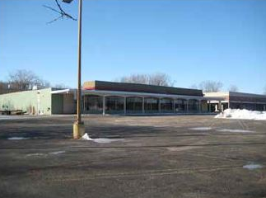
Above: The former grocery store at the corner of Maywood Ave. and Allen Blvd.
Top and bottom right: The Heritage Middleton Senior Campus.

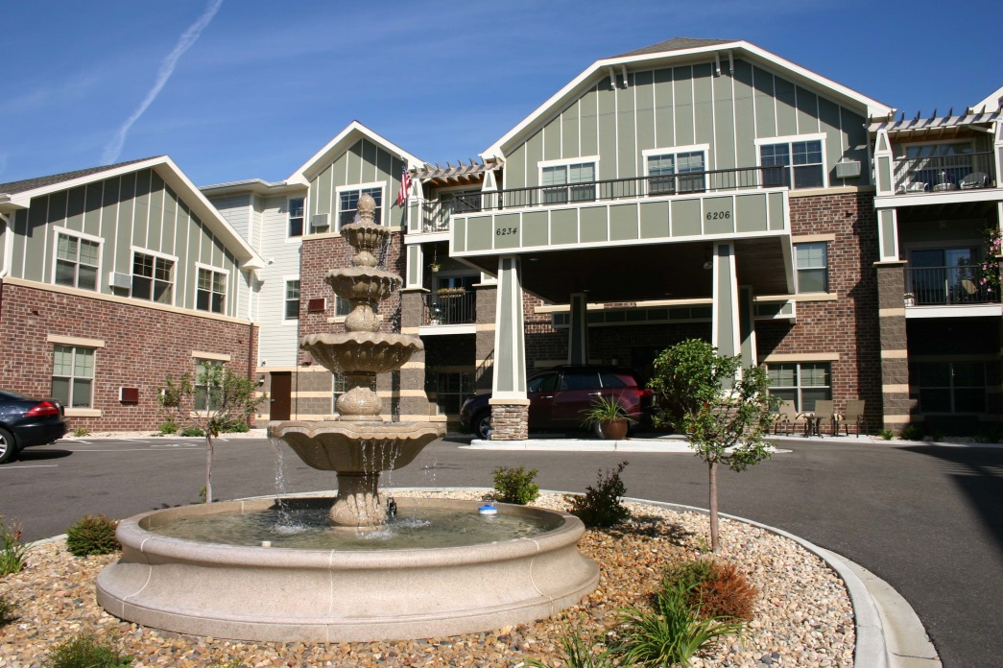

Amherst Road Residential Redevelopment
The City purchased five (5) duplex units on Amherst Rd. and provided relocation assistance to existing tenants. The City distributed a request for proposals for redevelopment of the property. The applicant selected by the City proposed that the five duplex units be replaced with ten (10) smaller single family homes and also requested TID #5 assistance of $16,000 per lot to cover costs including demolition of existing properties and site preparation. The City negotiated with the selected developer to provide one (1) of the ten single family lots to Habitat for Humanity. All ten lots have been developed, and the current assessed value totals over $2.2 million. The base value when TID #5 was created was just under $1 million. The City’s investment was the purchase price of $750,000, relocation assistance and $160,000 to the developer to assist with demolition and site preparation for the ten single family lots.
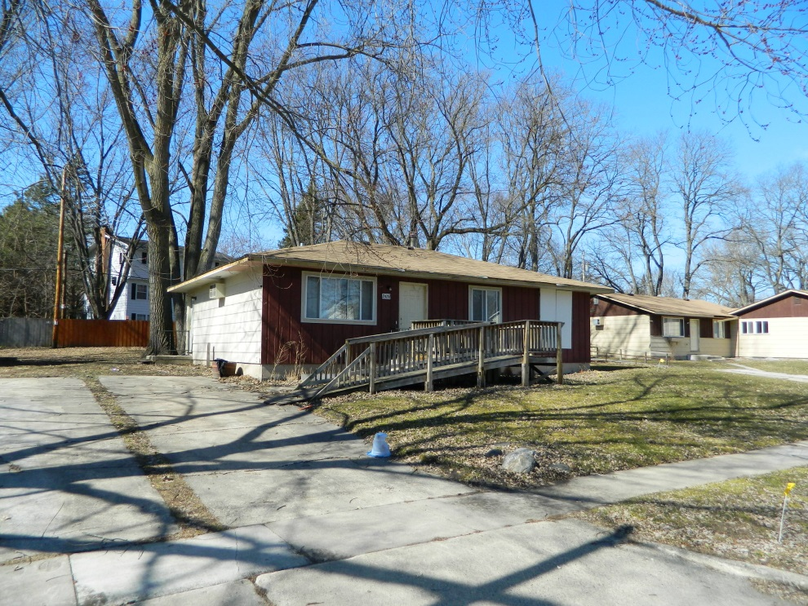
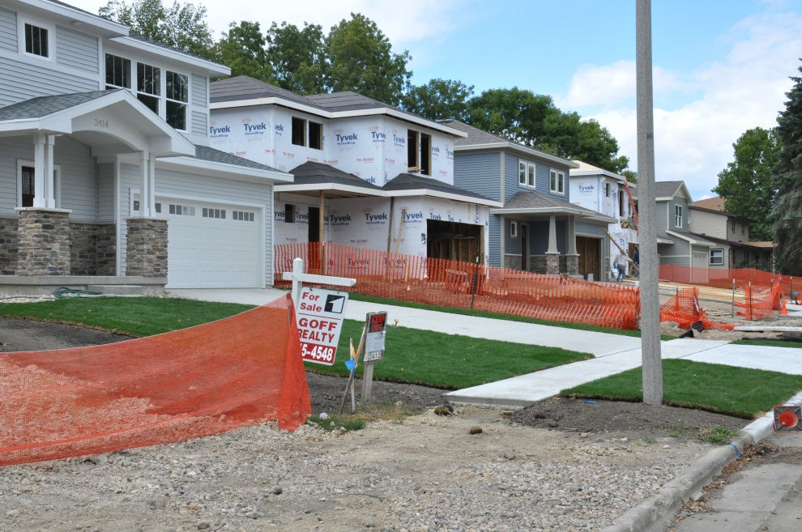
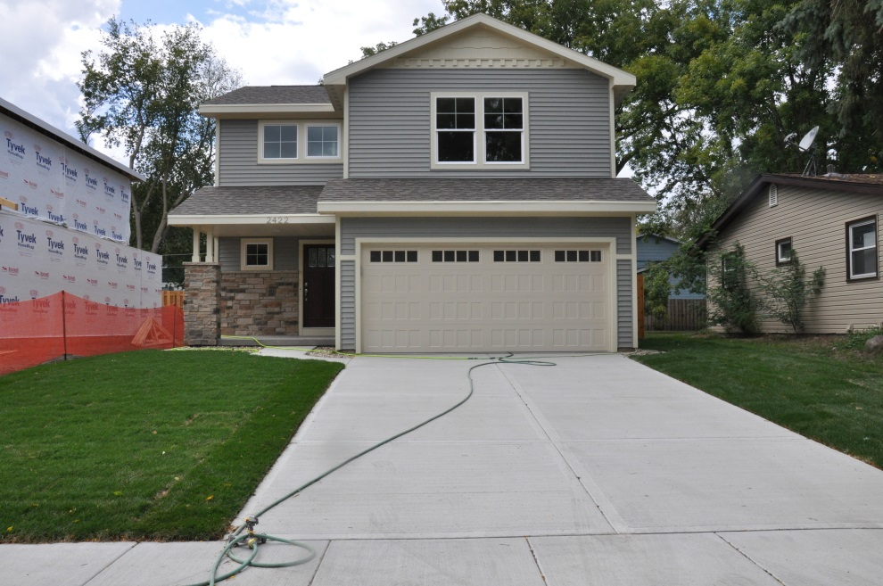
Top and bottom above: The new single-family homes on Amherst Road.
Left: The former duplexes on Amherst Road.

Approved Project
Meriter Middleton Medical Campus
The City has approved a project for Meriter, on approximately thirteen (13) acres south of Century Ave. and east of USH 12. The project consists of over 250,000 sq. ft. of ambulatory care facilities with a projected value of $80 million. TIF assistance will be provided at various stages of the project, for a total of $11 million. The assessed value of the 13 acres was just under $1.8 million when TID #5 was created. The TID assistance will help provide an increase in assessed value of over 4400%, with a return greater than 500% on the direct TID assistance. The project will also create additional employment opportunities and serve as a catalyst for more redevelopment in the area.
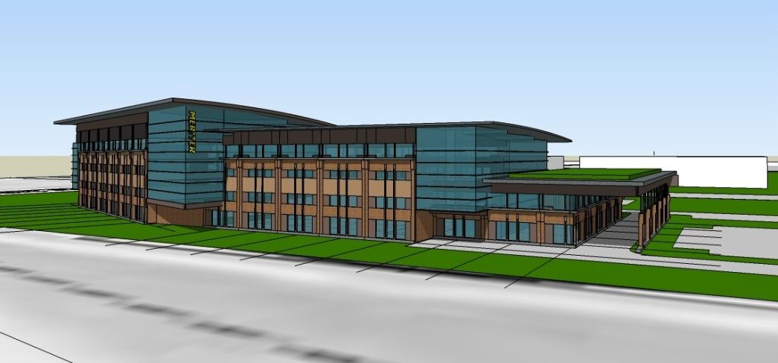
Partially Approved--Tribeca Village
This is a mixed use, high density project that will include offices, residential units, and regional and neighborhood retail uses. It is located north of Century Ave., between USH 12 and Parmenter St. The projected TID assistance is $18 million, with an expected value of over $200 million. The assessed value of the land in 2009 at the start of TID #5 was $415,700. Currently two apartment buildings, with approximately 115 units total, have been completed. The assessed value for the first apartment building is currently at $5.2 million.
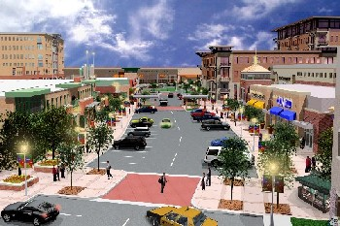
Above: A rendering of Tribeca Village
Left: A rendering of Meriter Middleton Medical Campus.

This report was compiled by Eileen Kelley, City of Middleton Planning Director. If you have any questions, please contact Eileen at (608)827-1070 or ekelley@ci.middleton.wi.us

