
City of Middleton:

Tax Increment District #3 Report

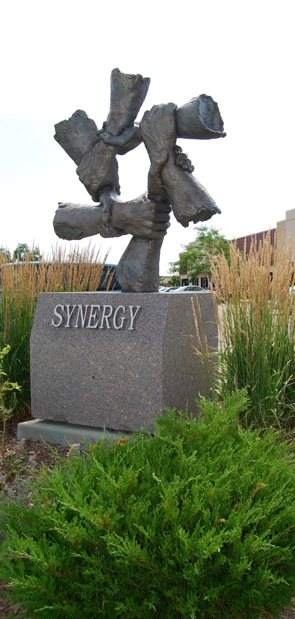
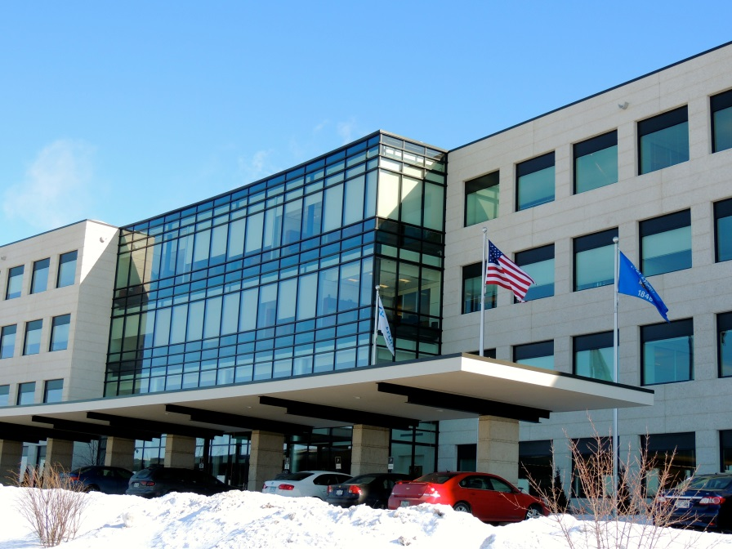
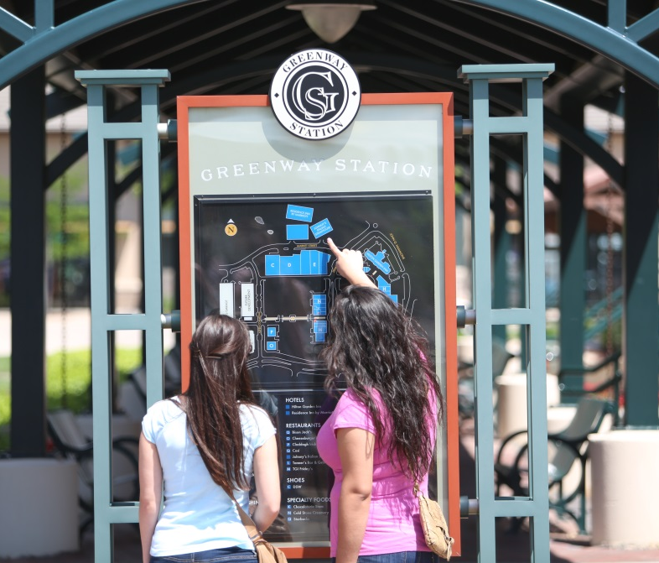
March 1, 2014


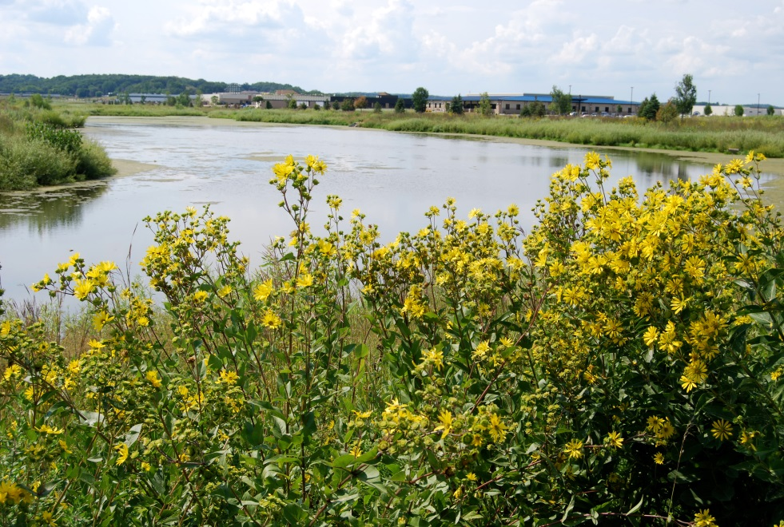

Introduction

The City of Middleton created Tax Incremental Financing District #3 (TID #3) in 1993. In the original 1993 TIF District 3 Project Plan, the base value of the TIF District was listed as $34.1 million. The projected expenses were $15.8 million, with projected new development of $44.9 million. The City has actually spent approximately $65 million on projects and more than $624 million of new tax base has been created to date.
In this report, the major expenses and added tax base in each district area will be briefly described. Since the 1993 creation of TID #3, there have been eight amendments to reflect additional projects, costs, increment value added, and to subtract property. The amendments will be discussed later in this document. For the sake of clarity, this report will compare the 1993 estimates with the actual numbers through 2013.

One of the primary reasons the City began to consider creating TID #3 was due to the large urbanizing floodplain that had been identified by the Wisconsin Department of Natural Resources in the late 1980’s, adjacent to the South Fork of the Pheasant Branch Creek. This meant that an area that had been annexed for growth, and that was adjacent to two major highway corridors and capable of being served by urban services, was unbuildable unless a funding mechanism could be found that would facilitate a multi-million dollar floodplain improvement project. The floodplain project was too expensive for individual property owners to absorb on their own, even if the City specially assessed for the costs.
The goals for the floodplain project were adopted by the Common Council on June 19, 1991, and are listed below:
- Reduce the 100-year floodplain; thereby increasing buildable acreage within the City limits
- Improve flood control through construction of detention ponds
- Attenuate downstream flooding
- Improve water quality
- Expand the use of the environmental corridor, creating a multi-use recreational facility
- Extend park multi-use trail system from RMI to the City limits

When considering the extent and scope of TID #3 in 1993, the City and its consultants, Vandewalle and Associates, determined that the use of TIF could assist with:
- comprehensive infrastructure development
- the full development of land within the district
- creation of one of the largest “job park” districts in the metropolitan area
A related goal for TID #3 was the elimination of the economic blight created by the urbanizing floodplain that was created by development of land primarily outside of the City’s boundaries. Another major goal for TID #3 was the continued redevelopment and restoration of the City’s historic downtown, which had first been addressed by the City in TID #1.
The project plan for TID #3 identified five major districts which will be described in this report:
- Stormwater Management District
- Greenway Center District
- Downtown District
- Airport Rd. District
- Existing Highway 12 District
Stormwater Management District
The primary goals of the stormwater management district were to minimize stormwater impact and promote water quality while increasing developable land for economic development purposes.

This district included:
- Design of a stormwater management system
- Comprehensive environmental and recreational design and implementation
- Land use and neighborhood planning
- Economic development strategies related to channelization

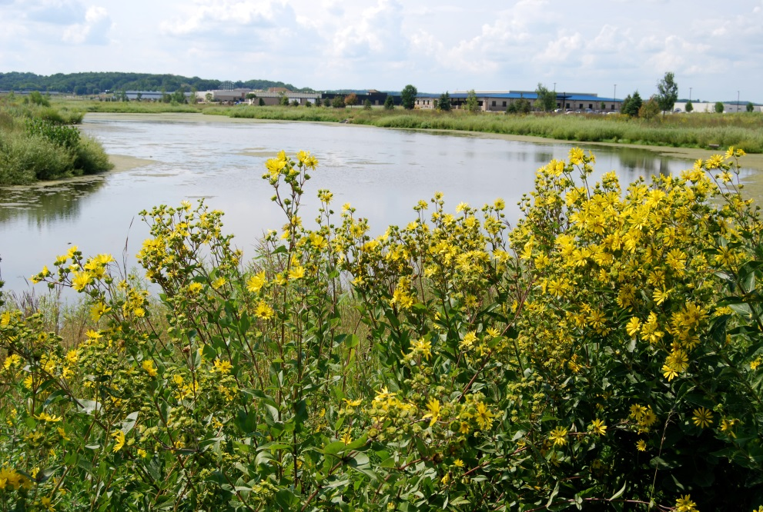
Above: The Confluence Pond was built with TID #3 funds as part of the City’s stormwater management/floodplain improvement project.

The estimated costs for projects in this district were $3.915 million, with expected new tax base of $14 million. The actual amount spent in this category was close to the projection, at approximately $3.945 million. The tax base created, however, far exceeded the original projections.

Each district created by the TID #3 plan benefited from the floodplain improvements. Although major projects and tax base created will be discussed individually by district, it is important to note that more than $300 million worth of tax base has been allowed to be created as a direct result of the floodplain enhancements. In Greenway Center alone, approximately $185 million of new development occurred, most of which would not have been possible without the floodplain improvements. The goals set by the City in 1991 for the channel improvement project were achieved, as was the creation of a large “job park” and tax base more than 21 times the original estimate.
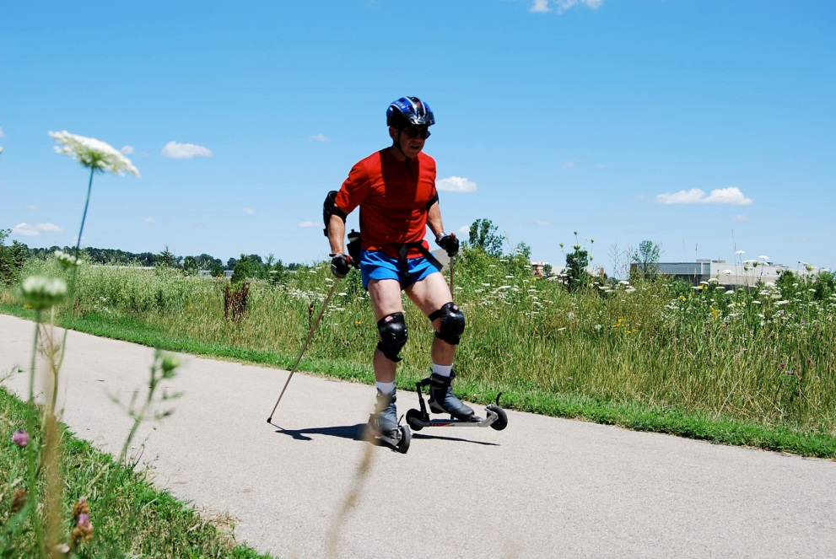
Above: A recreation trail adjacent to the Confluence Pond.

Greenway Center
In the City’s 1988 Southwest Area Study, this district was identified as “likely to be the most important development area in the City of Middleton during the next decade”. The Southwest Area was ideally situated as one of the strongest emerging markets for office and commercial development. The designation of the urbanizing floodplain in 1988, however, blighted the property and necessitated the channel improvement project.
The major projects completed in this district include:
- Extension of Greenway Blvd
- CDA lease revenue bonds to build a parking garage for increased density
- Road construction and reconstruction
- Stormwater improvements
- Bike path construction
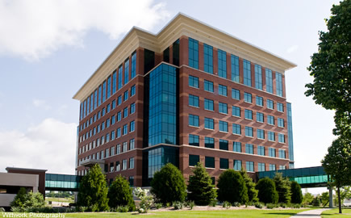
Above: The Greenway Office Building on Aspen Commons in Greenway Center.

In addition to the money spent on the channel project, the City also assisted in the development of a parking garage and other infrastructure improvements in Greenway of about $12 million. As stated above, this district also benefited from the floodplain project and enhanced environmental work. Current assessed values for this area are approximately $185 million, which is nine times the original projected estimate of $20 million.
Recent projects in this area include the expansion of an existing building to accommodate the Veteran’s Health Administration and expansion of several businesses including PPD.
Major employers in this area include:
- PPD (685 employees, 2nd largest biotech firm in Dane County)
- Veteran’s Health Administration (375 employees)
- West Corporation (340 employees)
- Humana Inc. (306 employees)
- Capitol Indemnity Corporation (250 employees)
- WTS Paradigm
- US Geological Survey
- Smith & Gesteland
- Clifton Larson Allen
- Raven Software
- Northwestern Mutual
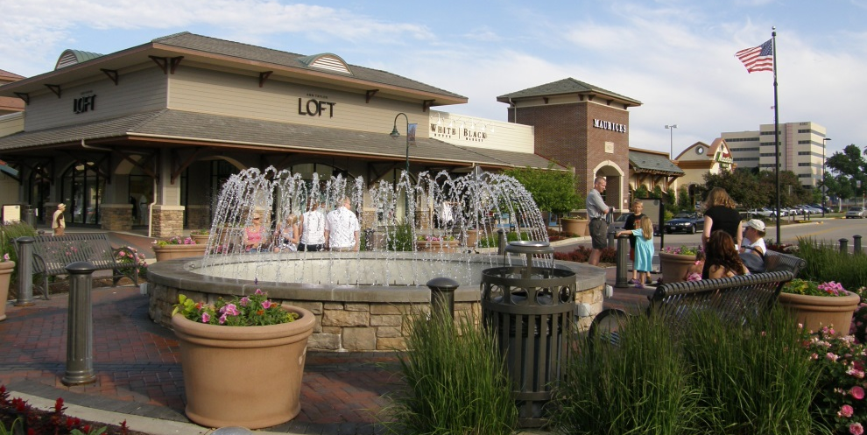

Downtown District
The 1993 TID #3 Plan placed an emphasis on revitalization efforts in the Downtown District. The main focus was on redevelopment, access to USH 12, streetscape and parking improvements. The City has spent approximately $15.5 million in TID #3 in the downtown and the Clark and Lee Street areas to date.
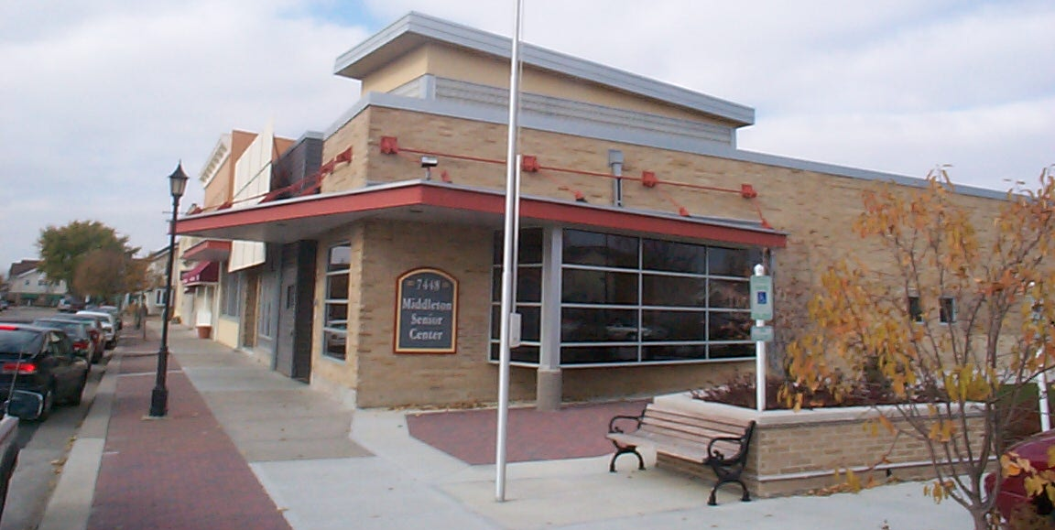
Above: The Middleton Senior Center in the former M & I Bank building.
Left: Greenway Station shopping center.

Projects included:
- Extension of Terrace Ave. from the downtown to Deming Way
- Acquisition, relocation, and demolition of: the M&I Bank building; Mid Plains storage building; Sawle property; EZ Tile; Decar; 2 furniture store buildings; Middleton Ford; and the Hotel Bar
- Quarry Park retaining wall
- Terrace Ave. parking lot construction
- Construction of Cayuga St.
- Reconstruction of Elmwood Ave.
- Senior Center building project / M & I Bank relocation
- Underground parking stalls for Cayuga Court project
- National Mustard Museum in the historic Friendly Store building
Upcoming projects include:
- Brick terraces and streetscape enhancements
- Terrace Avenue reconstruction
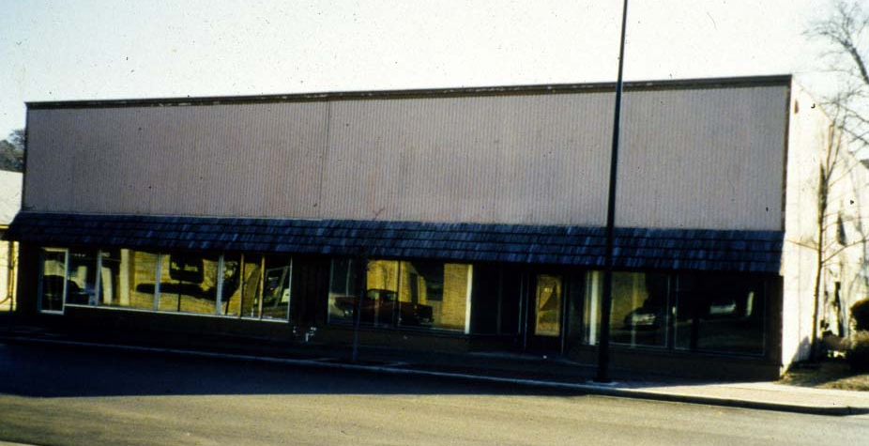
- Redevelopment / creation of housing east of Capital Brewery

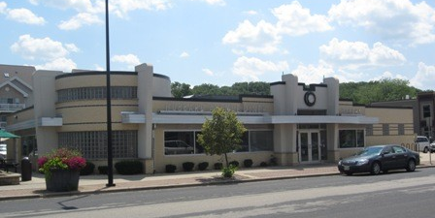
The City used TIF as a financing tool to effectively relocate land uses that were not appropriate in the downtown, such as a manufacturing facility, dilapidated buildings with inappropriate uses, and new and used car sales lots. As a result, the City assisted in the creation of vibrant land uses such as retail, restaurants and new housing, pedestrian friendly streetscape, and approximately $36 million of new tax base. In addition, the City utilized TID #3 funds to assist in the preservation of the historic “Pet Milk” Building, which was rehabilitated to accommodate nineteen residential condominiums.
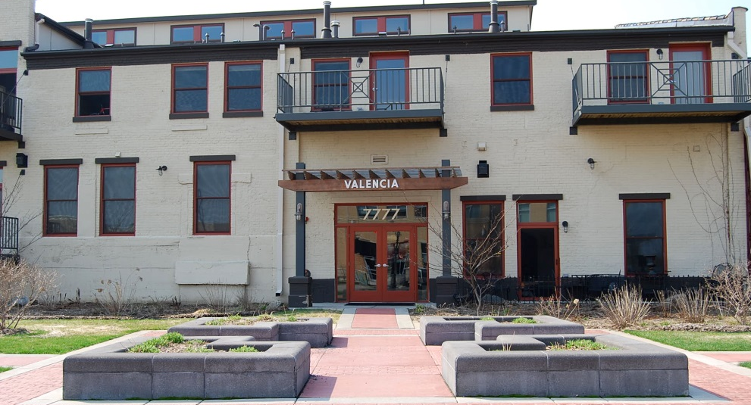
Above: Valencia Condos in the historic “Pet Milk” building.
Top Left: Former furniture store building, purchased by the City with TID #3 funds.
Bottom Left: New building / land use (Hubbard Avenue Diner) that resulted from the City’s use of TID #3 funds.

Airport Road District
The 1993 TID #3 Plan estimated project costs of $2.1 million in the Airport Rd. District, and projected increment value of $4 million. The City has spent approximately $17.9 million dollars on:
- significant public infrastructure projects to facilitate the appropriate development of large job parks
- acquisition and development of the airport
- acquisition of the Quisling property to enhance economic development and the floodplain improvements
- purchase of additional right-of-way for Airport Rd. and reconstruction from 2 lanes to 4 lanes
- Pleasant View Road construction from the business park north to Airport Rd.
- Reconstruction of the former USH 12 (now Parmenter)
- Development of Bike/Ped trails for bike commuter access
- Development of the Electronic Theatre Controls (ETC) site
An example of the success of the Airport Rd. District is the purchase of the Quisling property. Of the 220 acres purchased, approximately 60% of the land is used as permanent public open space, either as wetlands, prairie, bike paths or recreational fields. Approximately 40% of the land was used to accommodate several large employers, including the $25 million dollar facility that Electronic Theatre Controls (ETC) built, keeping 500 employees in the City of Middleton. (In 2008 ETC built an 80,000 square foot addition to their 250,000 square foot building.)
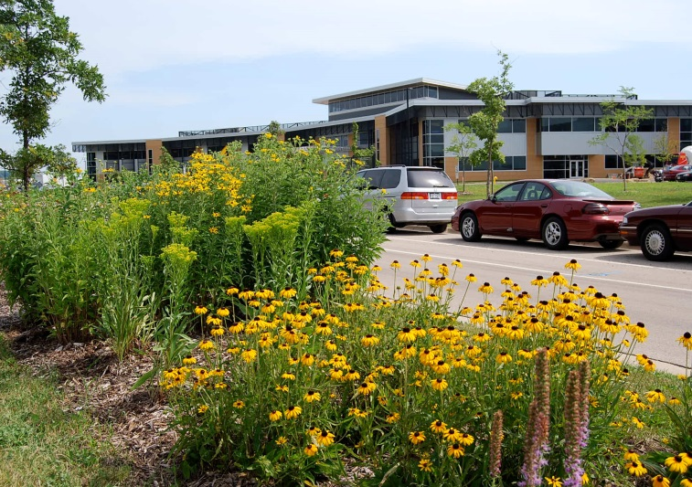
Above: Electronic Theatre Controls (ETC) national headquarters.

Natus Neurology is another large employer that will be located on former Quisling land with approximately 200 employees.
Recent projects include the construction of Spectrum Brands adjacent to USH 12, and the construction of buildings for two other businesses, ACD and ACS, as well as expansion assistance to keep Automation Components, Inc. in Middleton.

Some of the major employers in this area are:
- ETC (584 employees)
- Spectrum Brands (560 employees)
- Standard Imaging
- Nutra-Park
- Soft Switching Technologies
- ACD Distribution
- ACS
- Network Engineering Technologies
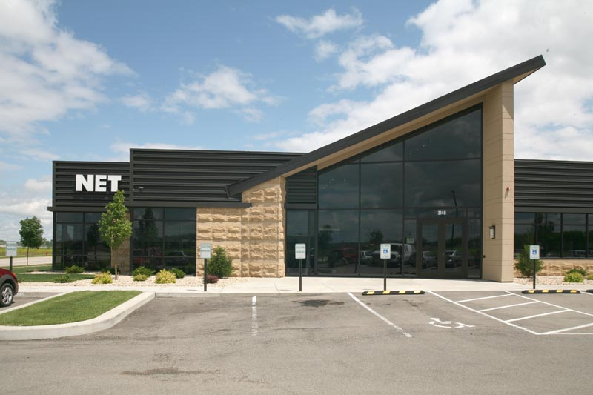
Above: Network Engineering Technologies (NET).
Top Right: Soft Switching Technologies.
Bottom Right: KEVA Sports Center.

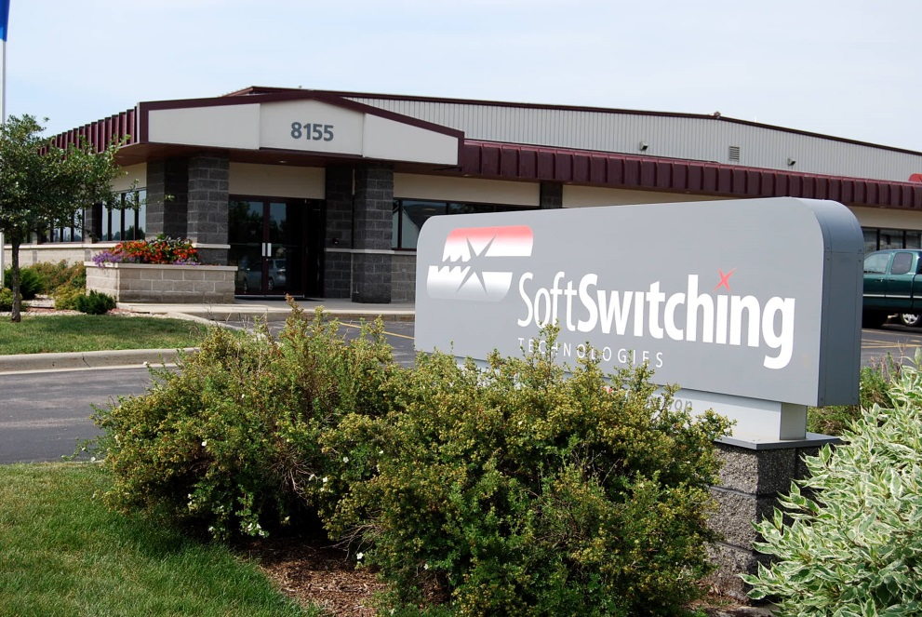
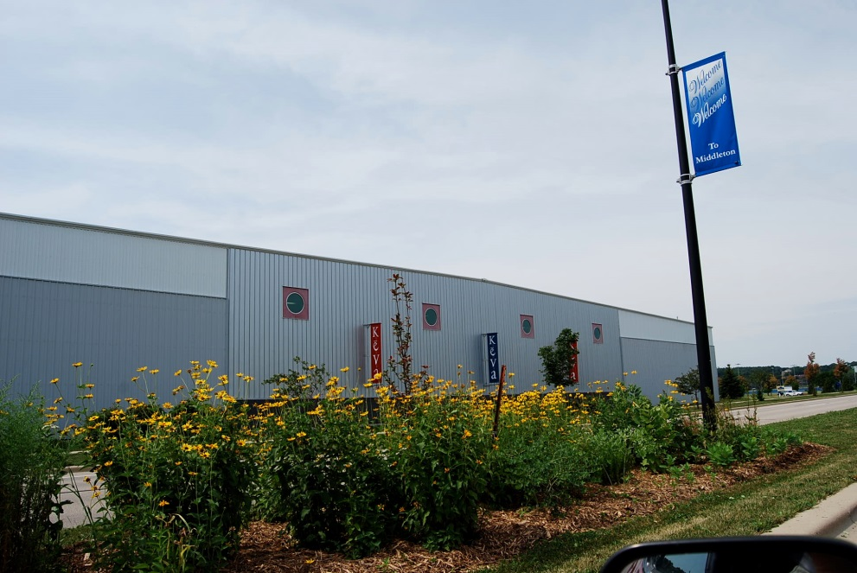
The tax base value created in this area is currently more than $116 million, with thousands of jobs in the area.
USH 12 District
The USH 12 District included projects along the former USH 12 corridor (now Parmenter St). The former highway section was rebuilt as a City street complete with highway off-ramp with TID #3 funds. Also, a bike/pedestrian connection was created linking the corridor to the west side employment areas at the Pheasant Branch Creek.
Parts of this area are now in TID #5 due to an “overlay” of the area when TID #5 was created in 2009.
Discovery Springs
The work completed by the City on the floodplain Improvements allowed the development of the Discovery Springs Business Park, with a tax base value of over $75 million, and many large employers including UW Medical Foundation with 650 employees. Recent projects in this area include a projected $11 million building for Mead & Hunt.
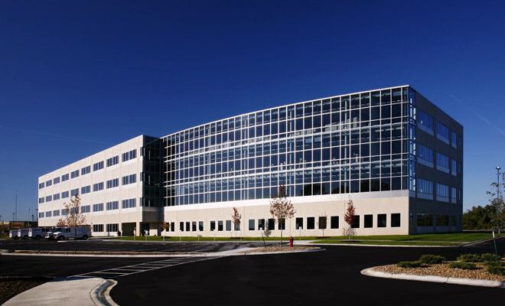

Major employers in this area include:
- UW Medical Foundation (650 employees)
- Costco (220 employees)
- Mead & Hunt (200 employees)
- Meicher & Associates CPAs
- TDS Telecom
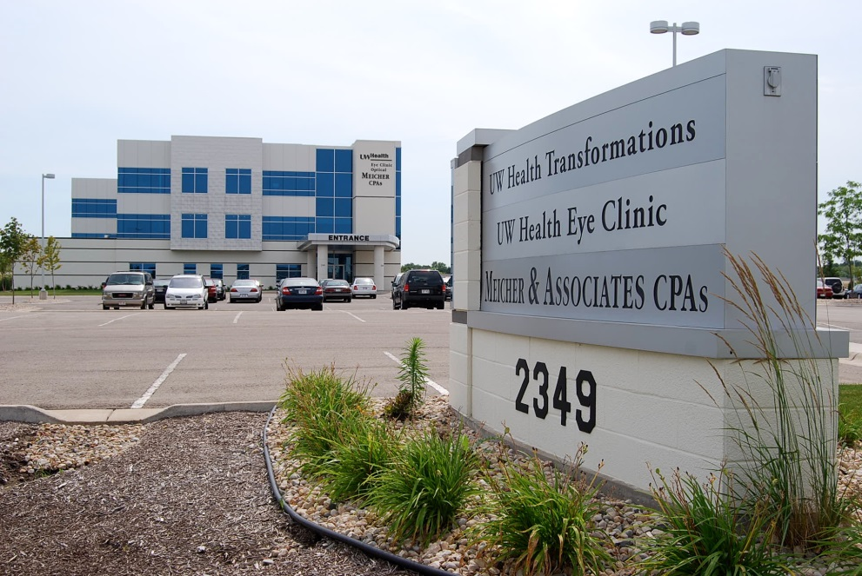
Above: UW Health Clinic and Meicher & Associates CPAs.
Left: UW Medical Foundation.

Amendments to TID #3
The City has amended the TID #3 plan a total of eight times through the end of 2013. Four of the amendments were boundary changes, including one where property was added. Three of the amendments were subtractions of property and value, adding approximately $274 million to the tax base of the taxing jurisdictions, including the City’s general fund. The other four amendments were revisions to the TID #3 Project Plan for various projects, expenditures, and developer financed TID assistance. The current increment value in TID #3 is $350,303,000.
This report was compiled by Eileen Kelley, City of Middleton Planning Director. If you have any questions, please contact Eileen at (608)827-1070 or ekelley@ci.middleton.wi.us

Above: TID #3 boundary with all of the amendments.

