
BASICS
The City of Middleton is considering an increase in Stormwater Utility rates, which a referendum will decide on the November 5th ballot. State law requires that property taxes be reduced by the amount collected by the Stormwater Utility unless voters approve the referendum to NOT reduce the current tax levy. Your vote is essential in this decision. We encourage all residents to learn about the referendum and make their voices heard at the polls.
HISTORY
Middleton voters approved the creation of the City’s Stormwater Utility in 2014 and permitted the utility to charge a quarterly fee of up to $3.75 per “equivalent runoff unit,” or ERU, from each property in the City. In 2018, voters approved a referendum permitting the annual charge to go up to $11.25 per ERU for the years 2019 through 2024 only. Middleton needed the additional revenue to pay for repairs to stormwater management features that were damaged by the August 2018 flood. This temporary increase will expire at the end of 2024, and the annual fee will drop to $3.75 in January 2025 unless Middleton voters approve another referendum.
WHY INCREASE THE RATES?
If approved, the referendum will do two things.
It will generate enough revenue to fund a comprehensive stormwater management program.
Our current program funding isn’t meeting our growing needs for stormwater management. Infrastructure is aging and needs to be maintained. Regulatory requirements are growing. Storms are becoming stronger and more frequent – the flood of 2018 caused over $40 million in damage to public and private property. The City needs to invest much more than it currently does on building and maintaining stormwater management facilities and operating a comprehensive program. Starting in January 2025, rates would be based on actual costs as determined by rate studies, just like how rates are set for our water and sewer utilities.
It will distribute the cost for city services more fairly across all properties in the city.
A comprehensive stormwater management program includes activities like street cleaning and yard waste pickup. The city provides these services to keep pollution (including nutrients from yard waste) from entering our public waters. We pay for these activities now using property taxes, which fall disproportionately on homeowners. Government facilities, churches, and other properties that aren't taxed don't pay for these services. By folding the cost of these services into our stormwater utility fee, the burden will be more fairly shared by all properties in the city. Rates will be based upon the stormwater runoff that each property generates. As shown in the charts, the stormwater utility shifts the funding burden away from residential properties and towards non-residential properties with more impervious area.
WANT MORE INFORMATION? cityofmiddleton.us/stormwater
¹ Comparison of funding City of Middleton stormwater services through property taxes vs. a utility fee system
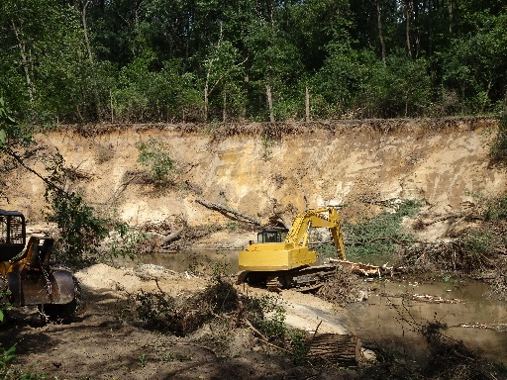
CALCULATING THE FEE RATE
Since the stormwater utility was established in 2014, the rates were set somewhat arbitrarily rather than based on actual needs. In 2023, the City’s Stormwater Utility Board directed staff to conduct a Rate Study to determine the actual program costs necessary to fund a comprehensive stormwater management program. The study recommended an annual rate of $92 per ERU, or $23 per quarter, in today's dollars. Based on this, the board proposed a referendum for voter approval.
A stormwater utility customer is any landowner with developed property that generates runoff into the City’s system. The fee is based on the amount of impervious surface (like pavement or roofs) on the property, measured in Equivalent Runoff Units (ERUs). Single-family homes and each unit in a duplex, triplex, and condominium are assigned one ERU. For other types of properties, the fee is calculated based on measurement of their impervious area. For instance, a commercial property with ten times the impervious surface of a single-family home would be charged for 10 ERUs.
Municipality² | Quarterly ERU Rate²
Sun Prairie | $ 36.15
Madison | $ 35.16
McFarland | $ 30.00
Fitchburg | $ 25.82
Monona | $ 24.15
Middleton  (with referendum) | $ 23.00
Verona | $ 21.25
Middleton  (without referendum) | $ 3.75
WHAT DO OTHER MUNICIPALITIES DO?
More than 120 Wisconsin municipalities have established stormwater utilities. If voters approve the referendum in November, our proposed 2025 quarterly rate of $23 per ERU would still be lower than that of all but one of our peer cities².
REFERENDUM QUESTION
Here is the question that will appear on the ballot:
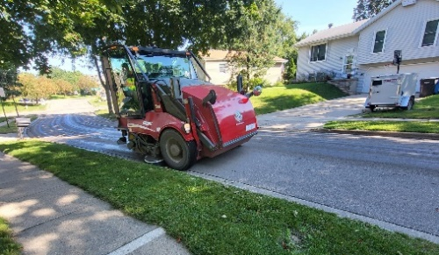
“Under state law, the increase in the levy of the City of Middleton for the tax to be imposed for the next fiscal year 2025, is limited to 1.0% (based on the City’s best estimate), which results in a levy of $21,181,184.
Shall the City of Middleton be permitted to charge customers of the Stormwater Utility, a quarterly charge per equivalent runoff unit that is adequate to fund the City’s stormwater management program and to maintain compliance with State and Federal regulations without reducing the City of Middleton’s levy limit in 2025 and thereafter?”
Explanation:
Residential customers (single-family homes and units in duplexes, triplexes, and condominiums) would pay the fee for one ERU per year. The number of ERUs charged to all other properties (including multifamily, institutional, commercial, and industrial) would be based on their actual impervious surface area, converted to ERUs.
A “YES” answer means that you support the City of Middleton being able to charge Stormwater Utility fees for each ERU per quarter adequate to fund the Stormwater Utility, spread over all property owners producing stormwater runoff within the City of Middleton, without any reduction in the City’s allowable property tax levy. The Stormwater Utility fee rates would be determined from time to time based upon an analysis of the cost of operating the Stormwater Utility and the fee necessary to cover those costs. Beginning January 1, 2025, the fee would be $23.00 per quarter for each ERU. Future changes to the Stormwater Utility rates would be determined through study by the City Engineer, subject to approval by resolution of the Common Council.
A “NO” answer means that you do not support the City of Middleton being able to charge Stormwater Utility fees in excess of $3.75 per quarter for each equivalent runoff unit and that you want all costs not covered by the $3.75 per quarter fee to be paid for with property tax revenue.
WANT MORE INFORMATION? cityofmiddleton.us/stormwater
²Rates are based on a review of rates as published on each municipality’s website for an average single-family property, and are subject to change Version: 9/11/24 9:30am

